How to Make the Perfect Mojito!
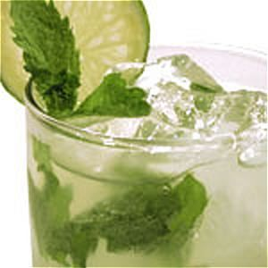
With summer just around the corner, what could be more perfect than a refreshing beverage on a hot summer night...or day for that matter. Whether you're having a barbecue or are just hanging out with friends, a mojito serves as the perfect drink to quench anyone's thirst. Here you will learn how to make the perfect mojito to leave all of your friends impressed.

Step 1: Get Your Ingredients!
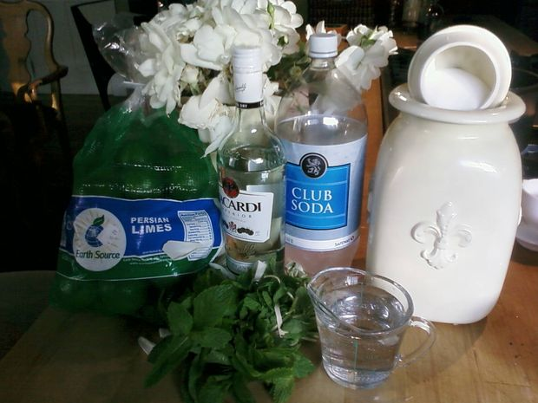
For your mojito you will need the following ingredients:
Mint leaves
Limes
Rum (We use Bacardi in this recipe)
Sugar
Club Soda
Ice'

Step 2: Make the Simple Syrup...its Simple Really.
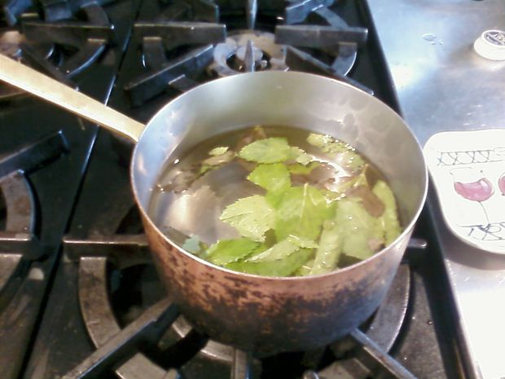
In order to balance the sourness of the limes in the mojito, we will use a simple syrup which is a fancy way of saying...sugar water. But what makes it even better is that we will be infusing it with mint to add to the flavor of the drink.
To make the simple syrup, dissolve sugar in water by heating it up in a saucepan on the stove. Use equal parts sugar and water. In this recipe we will use 1 cup water and 1 cup sugar. (If you wish to makes more mojito's, increase the ratio). Once the sugar has dissolved in the water, take it off the heat and add about 15 mint leaves and let them steep. Let the simple syrup cool. And remember, the longer it steeps, the more flavor your mojito will have.

Step 3: Squeeze Your Limes
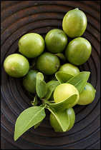
For a really good mojito, fresh lime juice is absolutely necessary. Don't try to take the easy road by buying pre-bottled lime juice...squeeze it yourself. Or better yet, it's always fun to get a friend in on the action so have THEM squeeze them for you! Working collaboratively can be great!
Note: Keep in mind that each individual mojito usually needs 1-2 limes depending on size.
Tip: Roll your limes on the counter before you squeeze them to get the juices flowing!

Step 4: Prepare Your Glasses!
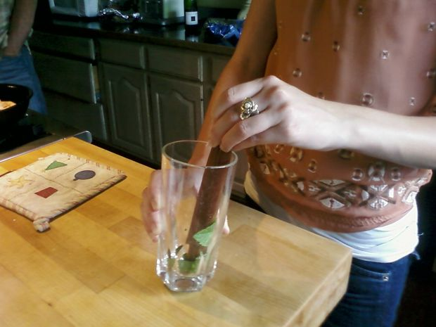
While you're waiting for the simple syrup to steep and cool and your friend is squeezing the limes...get your glasses ready to serve.
To do this, place a few mint leaves in the bottom of each glass and muddle muddle muddle. If you don't have a muddle, just use a fork to basically press and break up the mint leaves into the bottom of the glass and up the sides. This releases the essence and flavor of the mint leaves. Mmm Mmm..minty freshness.
When you're ready to serve, place ice to about half way in each glass.

Step 5: Construct Your PERFECT Mojito!
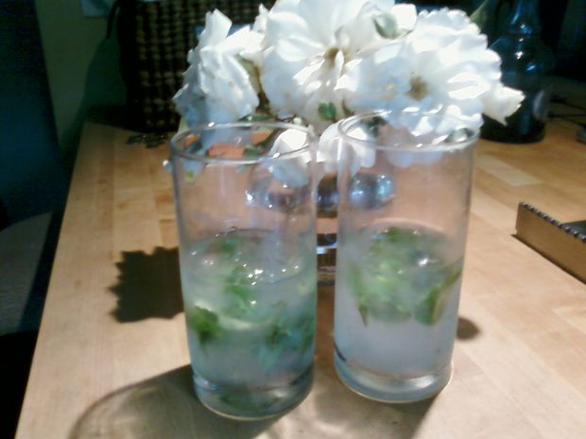
When you're just about ready to serve you can start to make your mojito.
After many trials I have found the prefect ratio of ingredients for the best mojito. To each glass with mint and ice, add the following:
2 ounces rum
1 ounce lime juice
1 1/2 ounces mint infused simple syrup
Top with a splash (literally just a splash) of club soda
And Voila! The perfect mojito.
Mojito's are best enjoyed on a warm day with friends...although are perfectly acceptable to be consumed by yourself! Enjoy!

